

Allergy and Alerts for BCMA v3.0

RELEASE NOTES

PSB*3*58

January 2012

Department of Veterans Affairs
Product Development (PD)

Table of Contents

1. Introduction 1
2. Enhancements 3
2.1. Site Parameter for Non-Nurse Verified orders 3
2.2. Administering Non-Nurse Verified medication orders 4
2.3. Submitting a Missing Dose Request for Non-Nurse Verified Orders 5
2.4. Marking Multiple Non-Nurse Verified Administrations Held or Refused 6
2.5. PRN Effectiveness Entry Parameter 7
2.6. BCMA GUI Visual Indicator to reflect Provider Overrides/Pharmacist Interventions 8
2.7. BCMA Order Detail Report displays CPRS Provider Overrides/Pharmacist Interventions 9
2.8. Icon Legend Option Added to the View Menu 12
2.9. “Hover-Over” Capability Added to the VDL 13
2.10. Double Scan Detection and Messaging 13
2.11. Missed Medications Report Dialog 14
2.12. Missed Medications Report 15
3. Modifications 16
4. Patient Safety Issue Correction 17
5. Defect Fix for Remedy Ticket HD208693 17
6. Defect Fix for Remedy Ticket HD420754 17
7. New Service Requests (NSRs) Resolved 17
8. BCMA Online Help Update 18
9. Additional Information 18

Introduction

This document provides a feature summary of the Allergies and Alerts for Bar Code Medication Administration (BCMA) v3.0 project, patch PSB*3*58.

PSB*3*42, PSB*3*52, PSJ*5*254 and PSB*3*60 must be installed before PSB*3*58.
Installation instructions for PSB*3*58 are included in the patch description.

Patient Safety Issue correction, PSPO 1765, has been addressed by PSJ*5*253.

Highlights

Parameters
- New BCMA Site Parameter added to allow sites to prohibit administration of non-nurse verified medication orders, or to display a warning before administering non-nurse verified medication orders, or administer non-nurse verified medication orders with no warnings displayed. Non-Nurse Verified Orders to follow site parameters.
- Allowable time for Pro Re Nata (PRN) Effectiveness Entry parameter maximum increased from 240 to 960 minutes.
- BCMA site parameters to display facility division number instead of Internal Entry Number (IEN).

VDL/Messages
- Warning/Error messages added to display when administration of a non-nurse verified order is attempted depending on site parameters selected.
- Warning messages added to display when marking non-nurse verified administrations as Held, Refused, or Missing Dose depending on site parameters selected.
- Verified (“Ver”) column on Virtual Due List (VDL) highlighted in yellow indicating the existence of Computerized Patient Record System (CPRS) provider override reasons associated with the order. Summary of order checks and provider reasons will be displayed in the Order Detail Report.
- Summary of CPRS Order Checks, Provider override reasons and Pharmacist intervention information added to the BCMA Order Detail report.
- “Icon Legend” added to the View Menu so that when selected, a dialog will display showing icons used throughout BCMA, with their corresponding descriptions.
- Hover-over feature added to the BCMA VDL to display visual indicator when override/intervention reasons exist.
- New functionality added to test for double scan detection and messaging.

Dosage form of “Gum, Chewable” shall no longer prompt for quantity and units.

Missed Meds Report
- Verified (“Ver”) column added to the Missed Medications report showing the initials of the nurse who verified the order or three asterisks (***) indicating the order was not nurse verified.
- Missed Meds Report Dialog modified to reflect “Include Admin Status: Held, Refused” and the “Include Detail: Comments/Reasons” checkboxes defaulting as checked when the report dialog initially displays.

Patient Safety Issue Correction
- Patient Safety Issue, PSPO 1765, “Inpatient Medication Order with a Schedule of On-Call and a Schedule Type of Fill on Request does not appear on the BCMA VDL” has been resolved with PSB*3*58. Orders with On-Call schedules and any schedule type will display properly in BCMA.

BCMA Online Help System Update
- The Online Help system has been updated for both the BCMA Client and Site Parameters application.

Enhancements

Site Parameter for Non-Nurse Verified orders
In the BCMA Site Parameters application Graphical User Interface (GUI), a new option group labeled “Non-Nurse Verified Orders” with three mutually exclusive options: “Allow Administration (No Warning)”, “Allow Administration with Warning”, “Prohibit Administration” was added.

“Allow Administration (No Warning)” is the default setting. Below are examples of the parameter screens.
Example: Parameter Screen
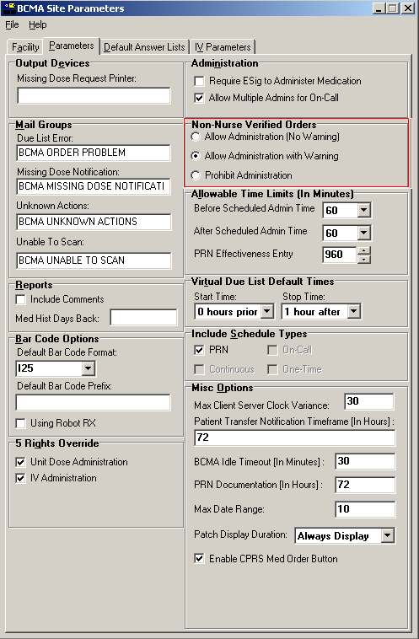

Administering Non-Nurse Verified medication orders
- When “Allow Administration (No Warning)” parameter option is selected:
If nurse initials are not displayed in Verified “Ver” column of the BCMA VDL for a particular order/administration, BCMA will allow the medication to be administered with no warning to the user.

Marking non-nurse verified administrations as Held, Refused, or Missing Dose will be unaffected by this parameter setting. Therefore, no warnings will be displayed.

- When “Allow Administration with Warning” parameter option is selected:
If nurse initials are not displayed in Verified “Ver” column of the BCMA VDL for a particular order/administration, BCMA will display a warning dialog with the message: “Order NOT Nurse-Verified! Do you want to continue?” when user scans the medication (or uses Unable to Scan).

The user has the choice of continuing the administration or cancelling the administration. Clicking OK will acknowledge that the order has not been nurse verified, and the user may continue the administration. All medication administration dialogs will display as appropriate to the workflow for the selected administration.
Clicking Cancel will display the “Order Administration Cancelled” dialog. User must click OK to acknowledge the cancellation and return to the VDL.

Example: Warning Message
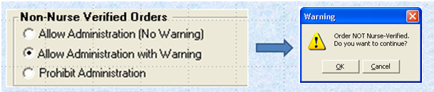

- When “Prohibit Administration” parameter option is selected:
If nurse initials are not displayed in Verified “Ver” column of the BCMA VDL for a particular order/administration, BCMA will display an error dialog with the message: “Order NOT Nurse-Verified! DO NOT GIVE!” when user scans the medication (or uses Unable to Scan).

Clicking OK to acknowledge the “DO NOT GIVE” message and clicking OK at the “Order Administration Cancelled” dialog will acknowledge the cancellation and return the user to the VDL without administering the medication.

Example: Error Message
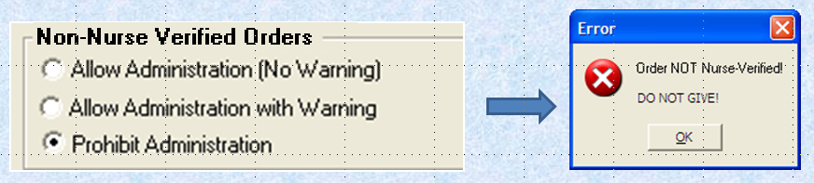

- When the “Allow Administration with Warning” or “Prohibit Administration” parameter setting is selected, the resulting warning/error pop-up message will usually precede other BCMA pop-ups during the medication administration process. Exceptions to this are:
  - Ward Stock Bags: When the user scans bag components into the Ward stock dialog thus creating a ward stock bag, BCMA will not match the list of components to the order until the user selects OK. At that time, if the order is not nurse-verified, the Non-Nurse Verify pop-up will then display. (Applies to IVP/IVPB and IV)
  - Multiple Orders for Scanned Drugs: When the user scans a medication and there are multiple administrations available within the virtual due list parameters timeframe, the Multiple Orders for Scanned Drugs dialog displays before the Non-Nurse Verify pop-up. (Applies to Unit Dose and IVP/IVPB)
  - Currently Infusing IV Bags: When attempting to scan a new bag while an existing bag is currently infusing, the user must complete the infusing bag before the Non-Nurse Verify pop-up displays. (Applies to IV)
- Site parameters for non-nurse verified orders do not affect the CPRS med order button functionality.

Submitting a Missing Dose Request for Non-Nurse Verified Orders
When submitting a Missing Dose request for non-nurse verified Unit Dose, IVP/IVPB, or IV orders, the user must perform one of the following actions:
- When “Allow Administration (No Warning)” parameter option is selected, no Warning message will display. The Missing Dose Request dialog box will display. The user may continue submitting the Missing Dose Request for the non-nurse verified order.
- When “Allow Administration with Warning” parameter option is selected, the pop-up dialog with the warning: “Order NOT Nurse-Verified! Do you want to continue?” will display.
The user must click OK to acknowledge that the order has not been nurse verified. The Missing Dose Request dialog box will display. The user may continue submitting the Missing Dose Request for the non-nurse verified order.
The user must click Cancel to cancel the request.
Example: Warning Message

- When “Prohibit Administration” parameter option is selected, the pop-up dialog with the error message: “Order NOT Nurse-Verified. Action unavailable until verified.” will display.
The user must click OK to cancel the selected action and return to the VDL.

Example: Error Message
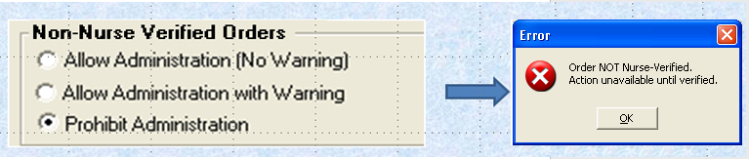

Note: User’s site policy will determine the correct workflow for verifying the order in CPRS.

Marking Multiple Non-Nurse Verified Administrations Held or Refused
- When “Allow Administration With Warning” parameter option is selected, if nurse initials are not displayed in the Verified “Ver” column of the BCMA VDL for a particular order/administration, when the user attempts to mark multiple administrations Held or Refused, BCMA will display a pop-up dialog with the warning: “You have selected one or more orders that are NOT Nurse Verified. Do you want to continue?”
User has the choice of continuing the administration or cancelling the administration.
  - Clicking OK will acknowledge that the order has not been nurse verified, and the user may continue the administration. Held or Refused dialogs will display as appropriate to the workflow for the selected action. All of the selected administrations will be marked appropriately.
  - Clicking Cancel will return the user to the VDL. No administrations will be marked.
Example: Warning Message
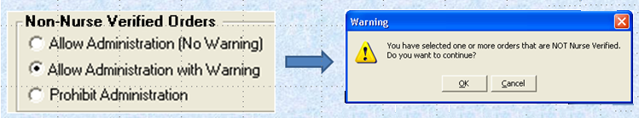
- When “Prohibit Administration” parameter option is selected, if nurse initials are not displayed in the Verified “Ver” column of the BCMA VDL for a particular order/administration, when the user attempts to mark multiple administrations Held or Refused, BCMA will display a pop-up error dialog with the message:“You have selected one or more orders that are NOT Nurse Verified. Do you want to continue?”
User has the choice of continuing the administration or cancelling the administration.
  - Clicking OK will acknowledge that the order has not been nurse verified, and the user may continue the administration. Held or Refused dialogs will display as appropriate to the workflow for the selected action. All of the selected administrations will be marked appropriately.
  - Clicking Cancel will return the user to the VDL. No administrations will be marked.
Example: Warning Message
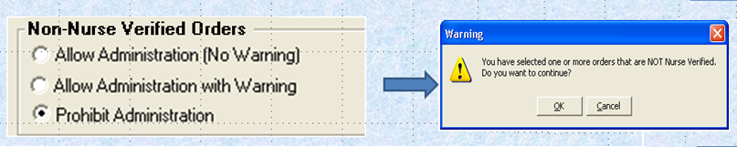
- PRN orders are skipped when checking the non-nurse verify status for a selection of multiple orders to be marked Held or Refused. Only non-PRN orders will trigger a prompt for held or refused non-nurse verified orders.

PRN Effectiveness Entry Parameter
The Allowable time for PRN Effectiveness Entry Parameter maximum has been expanded from 240 to 960 minutes.
- The drop down field has been changed to a spinner field.
- Numeric options in 10 minute increments are provided.
Below is an example of the parameter screen.
Example: Parameter Screen
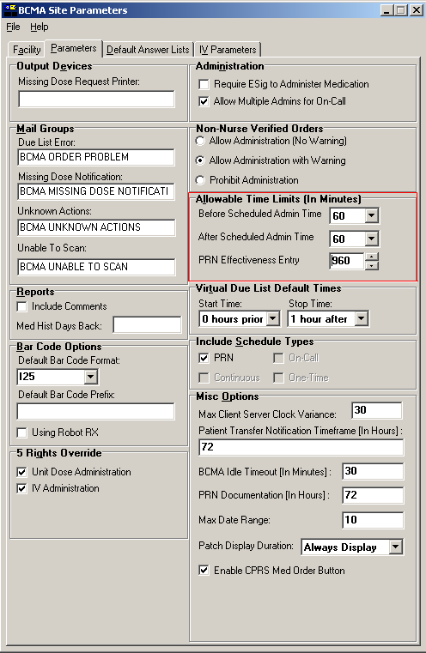

BCMA GUI Visual Indicator to reflect Provider Overrides/Pharmacist Interventions
A logical flag was created to pass from Inpatient Medications to BCMA, to indicate the existence of CPRS Provider override reasons and/or Pharmacist interventions associated with an order.

If the flag exists for an order, the cell in the Verified “Ver” column of the order/administration on the BCMA VDL is highlighted in yellow, to indicate the existence of CPRS Provider override reasons and/or Pharmacist interventions associated with the order.

- The highlighting of the Verified “Ver” cell is applicable to orders on all three medication tabs: Unit Dose, IVP/IVPB, and IV.
- The highlighting of the Verified “Ver” cell is applicable to orders on the Cover Sheet.
The Verified “Ver” column was added to the Cover Sheet tab to display either initials of the nurse who verified order, or three asterisks “***” to indicate the order is non-nurse verified.

Example: VDL Screen Excerpt


BCMA Order Detail Report displays CPRS Provider Overrides/Pharmacist Interventions
If CPRS Provider override reasons and/or Pharmacist interventions exist for an order, a summary of the order’s current CPRS Order Checks, Provider override reasons and Pharmacist intervention information will be included in the BCMA Order Detail report, below “Spec Inst”.

At the top of the summary, the following Provider Override information displays:
- Heading: **Current Provider Overrides for this order **
- “Overriding Provider:” (Provider Name and Title)
- “Override Entered By:” (User who entered justification and Title)
- “Date//Time Entered: ” (MM/DD/YY HH:MM)
- “Override Reason:” (Justification text)

Below the Provider Override information, the summary of current CPRS Order Checks will display in the following order:
- Allergies/Adverse Drug Reaction (ADR)s
- Critical drug-drug interactions
- All other interactions that were displayed in the CPRS Order Checks dialog at the time the order was signed.

BCMA Order Detail Report Variations:
- Both current CPRS Provider Overrides and current Pharmacist Interventions exist for a critical drug-drug interaction or an allergy/ADR associated with the order.

Example: BCMA Order Detail Report
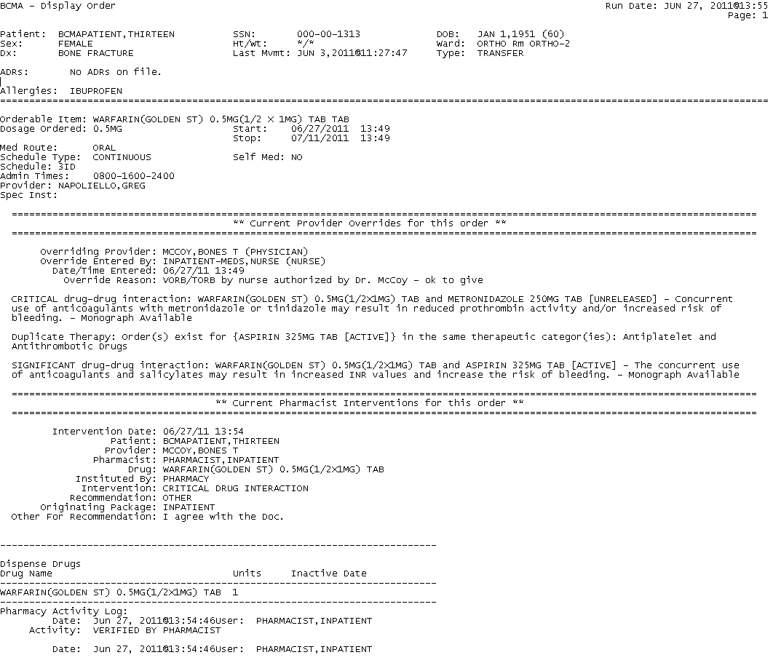

- A current CPRS Provider Override exists for a critical drug-drug interaction or an allergy/ADR associated with the order; No Pharmacist Intervention exists for the order.
Example: BCMA Order Detail Report
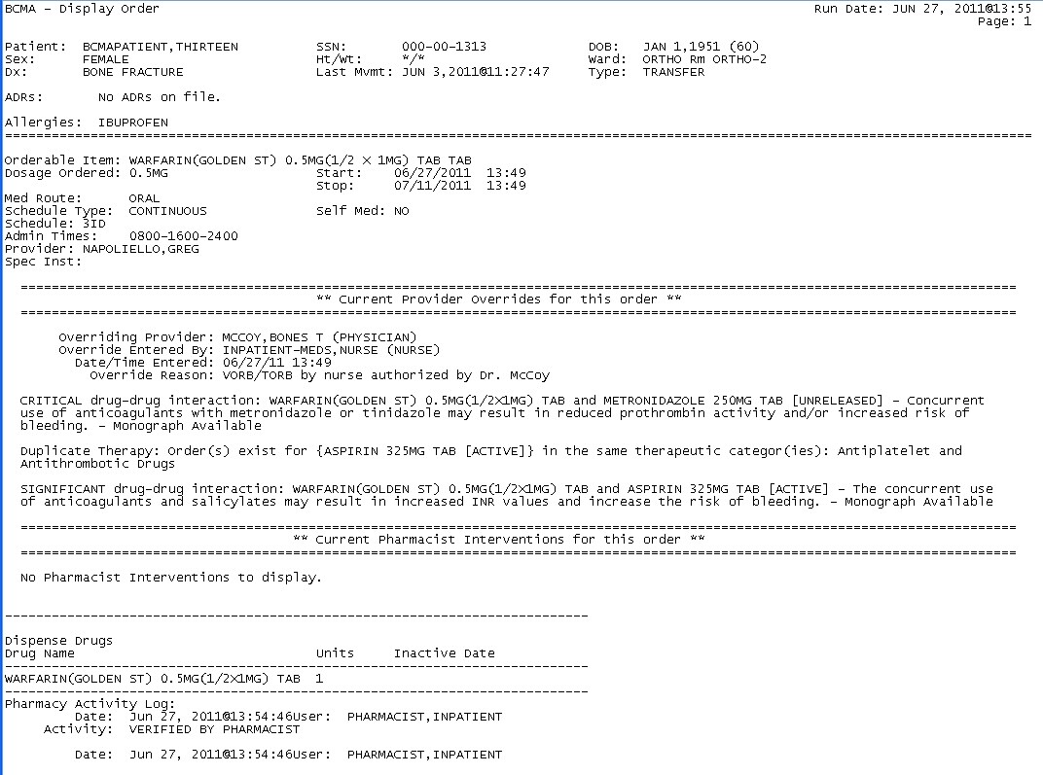
- A current Pharmacist Intervention exists for a critical drug-drug interaction or an allergy/ADR associated with the order; no CPRS Provider Override exists for the order.

Example: BCMA Order Detail Report
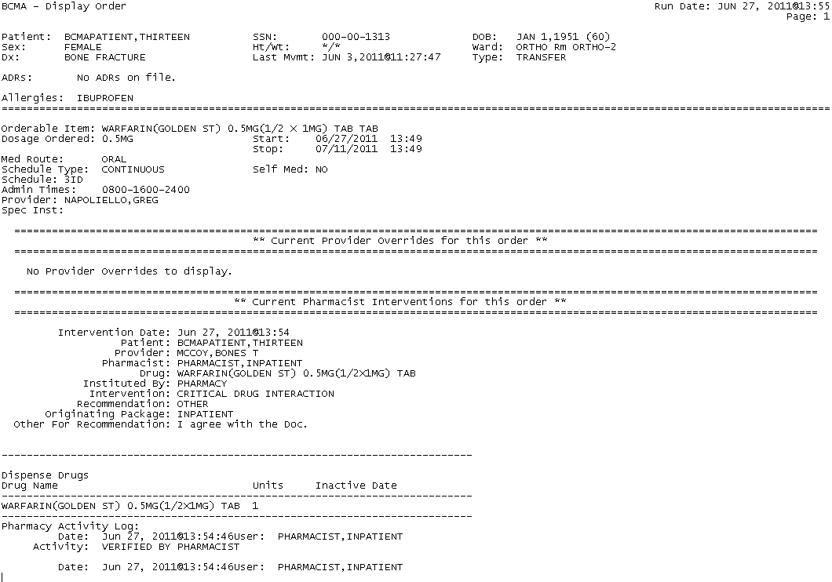

Icon Legend Option Added to the View Menu
A new menu option called “Icon Legend” was added to the View Menu so that when selected, a dialog will display showing icons used throughout BCMA, with their corresponding descriptions:
- Click on View then click on Icon Legend.
- Clicking OK will return the user to the VDL.
Example: Icon Legend
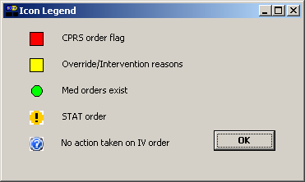

“Hover-Over” Capability Added to the VDL
A new hover-over feature was added to the BCMA VDL. When CPRS Provider Overrides and/or Pharmacist Interventions exist for an order, the user will be able to hover over the highlighted Verified “Ver” cell, and the following visual indicator will display: “Override/Intervention reasons.”
Example: Override/Intervention Indicator

Double Scan Detection and Messaging
Functionality was added to test for scanning of data into the Quantity and Units pop-up fields. The Double Scan routine tests for the following criteria and rejects input that matches:
- Integer only
- All–numeric string (out of range for integer)
- IV label: nnnVnn where n is a numeric digit
- Number and units: nnnnnU or nnnnn U where n is a numeric digit. A single U is also rejected.
Where double scanning occurs, e.g., a match is found for any of the first three conditions, above, BCMA will display a popup error dialog with the message: “Error. Incorrect or insufficient information entered. Please use the correct quantity and units. Examples: 5000 units, 2mg, 1 puff, small amount, 1 inch.”
Example: Error Message
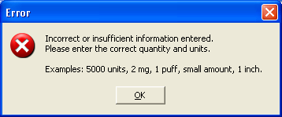

If ‘U’ or ‘u’ is entered, BCMA will display a popup error dialog with the message: “Error. ‘U’ or ‘u’ is not an acceptable abbreviation. Retype the entry using the word “units.”
Example: Error Message
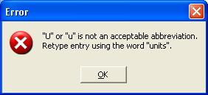

Missed Medications Report Dialog
The Missed Medications Report dialog was modified so that the “Include Admin Status: Held, Refused” and the “Include Detail: Comments/Reasons” checkboxes will be checked (selected) as a default when the report dialog initially displays.

These new default settings will always be in effect when the report is executed. The Comments/Reasons checkbox will be selected regardless of parameter settings for Reports-Include Comments. Upon display of the dialog, the user will be able to uncheck the boxes as desired.
Example: Missed Meds Report Dialog Box
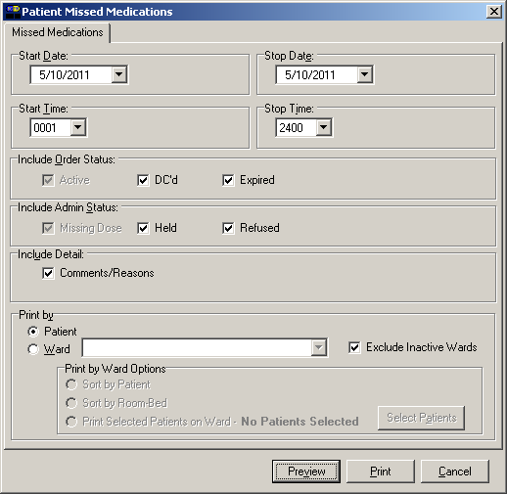

Missed Medications Report

The BCMA Missed Medications Report has been modified to add a Verified column showing nurse initials or asterisks in both By Patient and by Ward formats.
Example: Missed Medication Report by Patient
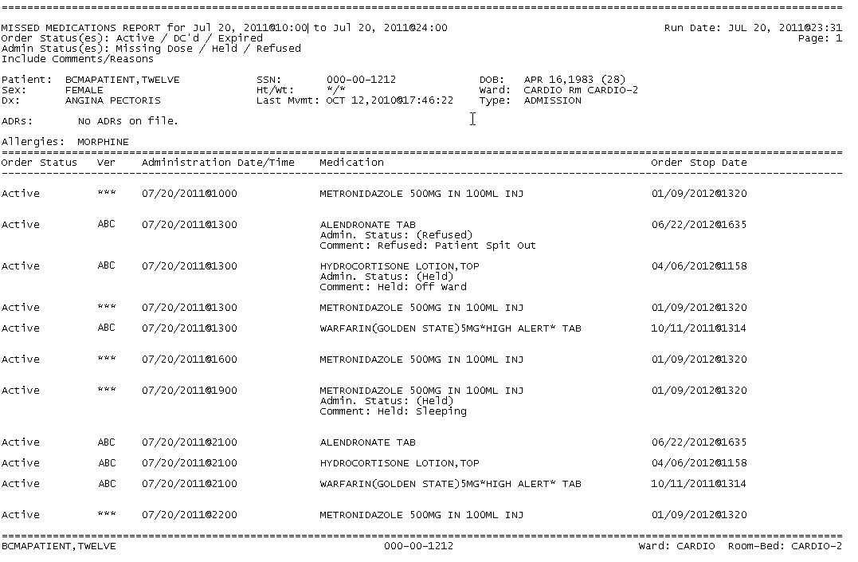

Modifications
The BCMA Site Parameters Program was modified to display facility division number instead of facility division IEN.

BCMA will test for scanning of data into the Quantity and Units Dialog Box. The following criteria is tested and input that matches is rejected: Integer only; all-numeric string (out of range for integer); IV label – nnnVnn where n is a numeric digit; and number and units – nnnnnU or nnnnn U where n is a numeric digit. A single U is also rejected.
If a match is found for any of the first three conditions, BCMA will display the following error message.
Example: Error Message
If ‘U’ or ‘u’ is entered, BCMA will display the following error message.
Example: Error Message

Patient Safety Issue Correction
PSPO 1765, “Inpatient Medication Order with a Schedule of On-Call and a Schedule Type of Fill on Request does not appear on the BCMA VDL” has been resolved with PSB*3*58.

If the name of an order’s schedule is “ON CALL”, “ON-CALL” or “ONCALL”, and the Inpatient order’s schedule type is “Fill on Request” or “Continuous”, the order is sent to BCMA as an On Call order type.

Schedules meant to cause orders to display as ON CALL in BCMA must be defined in the ADMINISTRATION SCHEDULE (#51.1) file with a schedule type equal to “ON CALL”.
With PSB*3*58, orders with On-Call schedules and any schedule type will now properly display in BCMA.

Defect Fix for Remedy Ticket HD208693

An administration with a dosage form of “Gum, Chewable” shall no longer prompt for quantity and units.

Defect Fix for Remedy Ticket HD420754
The BCMA Site Parameters program was modified to display the facility division number instead of the facility division IEN when the user clicks on “File” to make parameter changes.

New Service Requests (NSRs) Resolved
The following NSRs were resolved with this patch:

- 20110326
- 20071003
- 20070205

BCMA Online Help Update
The BCMA GUI Online Help system has been updated to include all released BCMA PSB*3*58 functionality. Online help for both the BCMA Client and Site Parameters application have been updated.

Additional Information
The following new Integration Control Registrations (ICRs) are associated with this patch:
- ICR #5653 – RETURN CPRS ORDER CHECKS AND OVERRIDES TO BCMA
- ICR #5654 – INPATIENT INTERVENTIONS TO BCMA

